**Prepare CSDR Work Instructions**

* Open Cobra – Open project with the “as of date” and save as:
* Example- Project: CSDR 04750815 Description: 0475 August 2015 CSDR



* Once Cobra is open and saved, open the following folder:

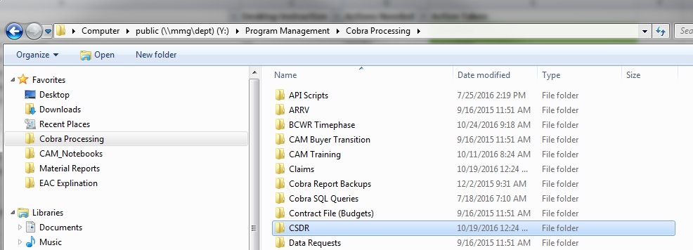

* If the Ship set is not listed in the CSDR folder, add a new folder and name it LCS XX CSDR
* If the Ship set is listed, open it.

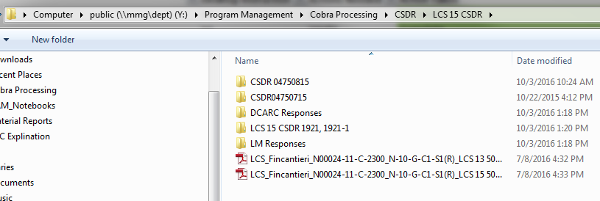

* Create a folder for the CSDR you are reporting on with the correct “as of date”. See example in the above screenshot.
* Next, in the same folder, open LCS XX CSDR XX-XX-XXXX with formulas (this is a template in which all CSDRs will be started from).
* Save as ‘LCS XX CSDR MM-DD-YYYY with formulas’ in the appropriate CSDR folder.
* Verify the following in Project Information in the Fields tab is updated like below. Do not update anything other than the part that is circled below:

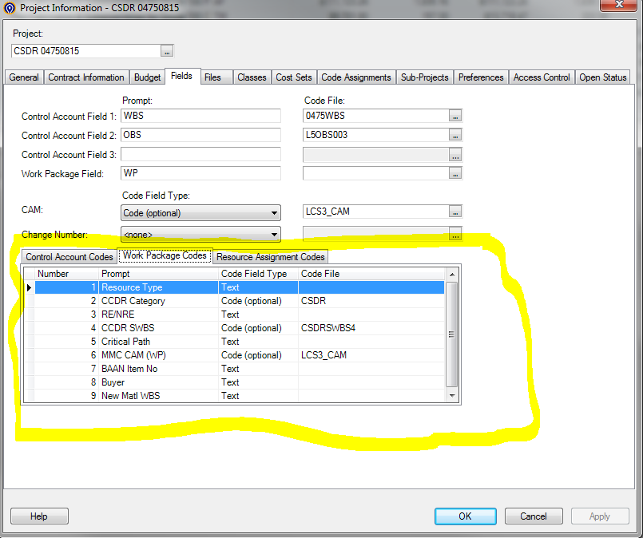

* In Cobra, navigate to Tools – SQL Command Utility from the toolbar. Below will pop up. Make sure this is addressed before running the Cobra report. This SQL statement is for 0477AF. After everything is highlighted, click Execute.

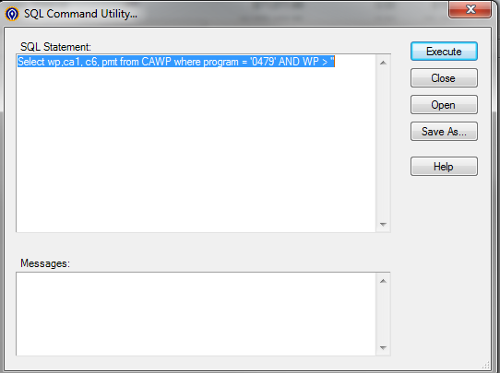

* Run a report in Cobra by clicking Report – Report Wizard on the Cobra toolbar.
* ‘Report’ screen – Type CSDR Project Cost Set and it should come up right away.
* Make sure you have the correct file in the file field - Click Next.

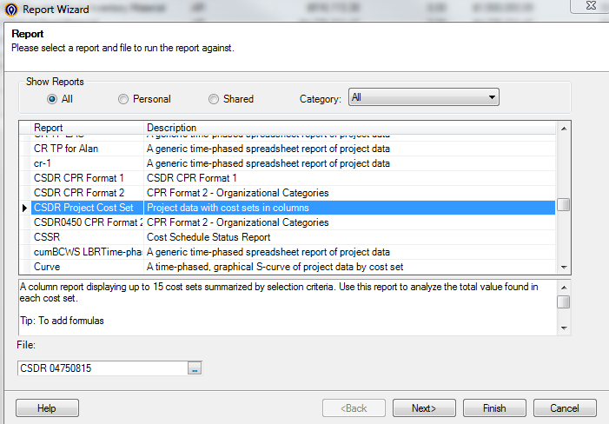

* ‘Filter/Sort’ screen - No filter – Click Next.

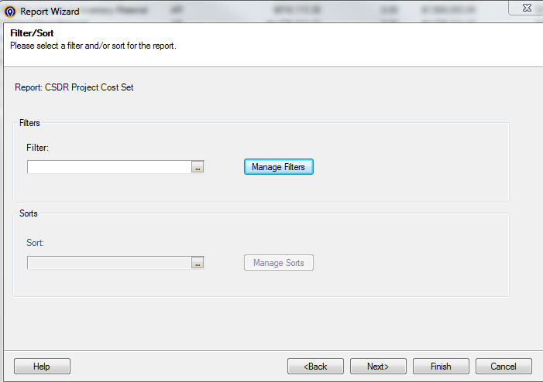

* ‘Sub-Totals’ screen – See screen shot below. Click next.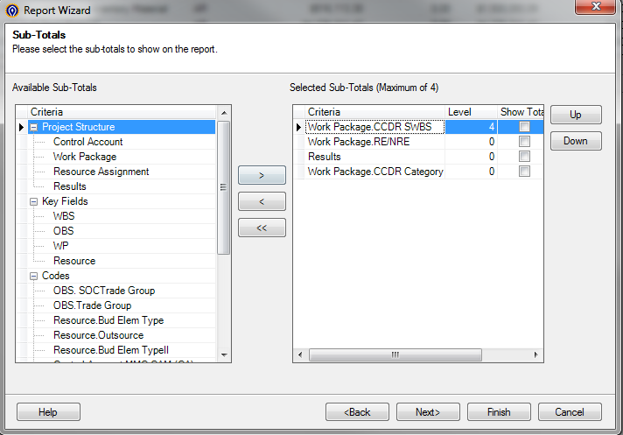
* ‘Results’ screen – See screen shot below. Click next.

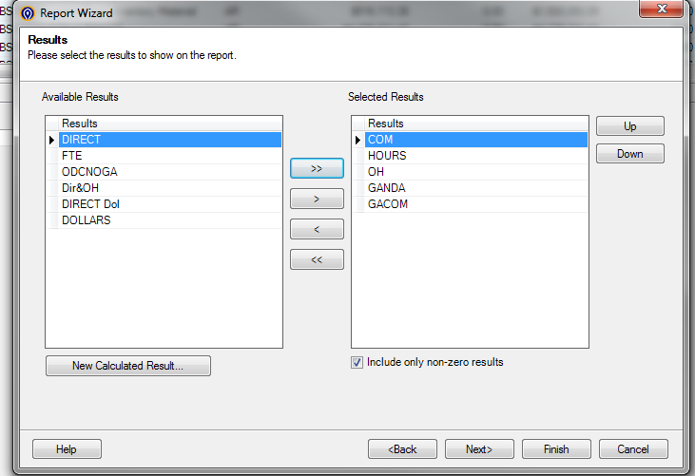

* ‘Cost Sets’ screen – See screen shot below. Click Next.

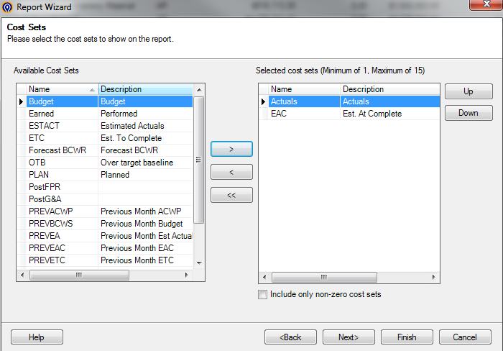

* ‘Style’ screen –See screen shot below. Click Next.

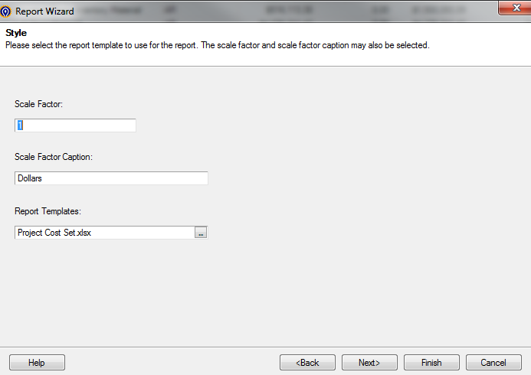

* ‘Save and Run’ screen – See screen shot below. Click Finish.

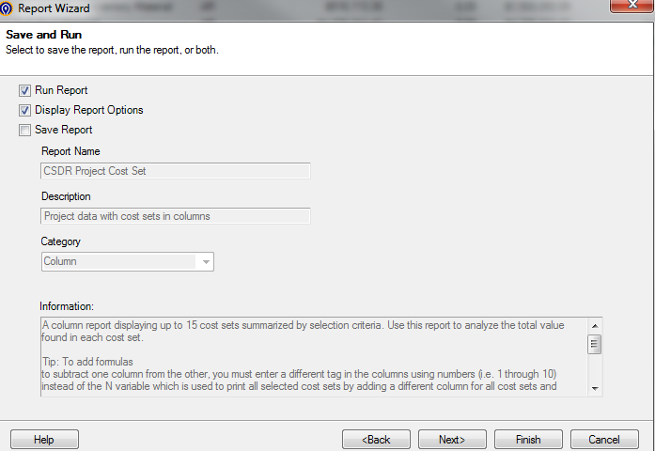

* Report will come out in excel.
* Expand the report out to the 4th level.

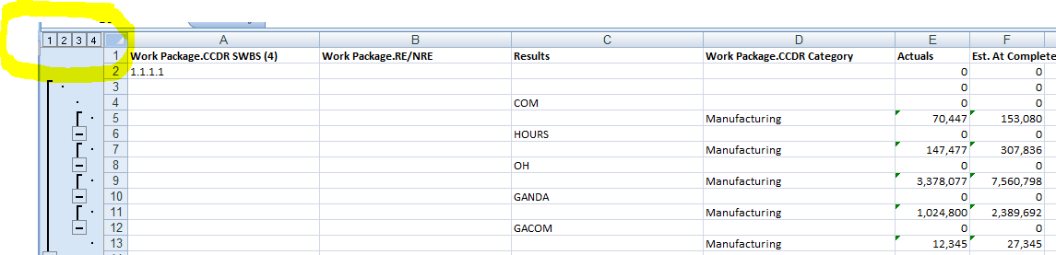

* Copy/Paste special values - all data from spreadsheet into the ‘Copy in Cobra Project Cost Set’ tab of the ‘LCS XX CSDR MM-DD-YYYY with formulas’ spreadsheet.
* Instructions are listed on the ‘Copy in Cobra Project Cost Set’ tab in Column H-I.
* Follow the instructions listed in the ‘Copy in Cobra Project Cost Set’ tab in Column H-I.
* Navigate to the ‘Header Lookup’ tab:
  + Confirm 1. Major Program a.) Littoral Combat Ship (LCS) and b.) must be C-FRP
  + Confirm 2. Prime Mission Product has “Seaframe” in it; nothing else.
  + Confirm 3. Reporting Organization Type has an “X” in ‘Direct-Reporting Subcontractor
  + Confirm 5. Approved Plan Number needs to be N-10-G-C1-S1(R)
  + Confirm 7.a.) Type Action Contract Number is N00024-11-C-2300
  + Confirm 8. Period of Performance has the correct start and end dates listed.
  + Confirm 9. Report Cycle is updated to correct CSDR.
  + Confirm 10. Submission Number is updated correctly.
  + Confirm 11. Resubmission Number is updated correctly.
  + Confirm 12. Report as of (YYYYMMDD) is updated to match the CSDR Plan.
  + Confirm 17. Date Prepared (YYYYMMDD) is updated to the submittal date.
  + Confirm 22. Remarks are all updated correctly
* Navigate to ‘CSDR Project Cost Set Formatted’ tab:
  + Confirm number of rows is equal to the number of rows in the ‘Copy in Cobra Project Cost Set’ tab.
  + Confirm all formulas are drug down from Column A through Column Q.
* Navigate to ‘PCW Spreadsheet Month Year’ tab.
  + Go to working files and copy/paste special values the **MOST RECENT** PCW spreadsheet into the ‘PCW Spreadsheet Month Year’ tab into Cell A1.
* Navigate to ‘1921’ tab.
  + Most numbers on this tab are v-lookups to the other tabs that have already been updated.
  + Confirm 8. Contract Price is equal to the ‘PCW spreadsheet Month Year tab’ for the corresponding Target Price (use the beige section, as this is the MMC value that matches the CPRs - highlighted circle below).

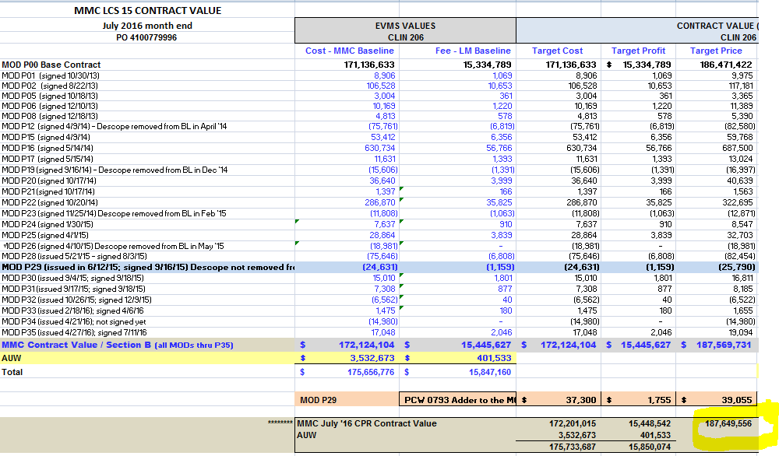

* Confirm 9. Contract Ceiling is equal to the ‘PCW spreadsheet Month Year’ tab for the corresponding Contract Ceiling (use the beige section, as this is the MMC value that matches the CPRs - highlighted circle below).

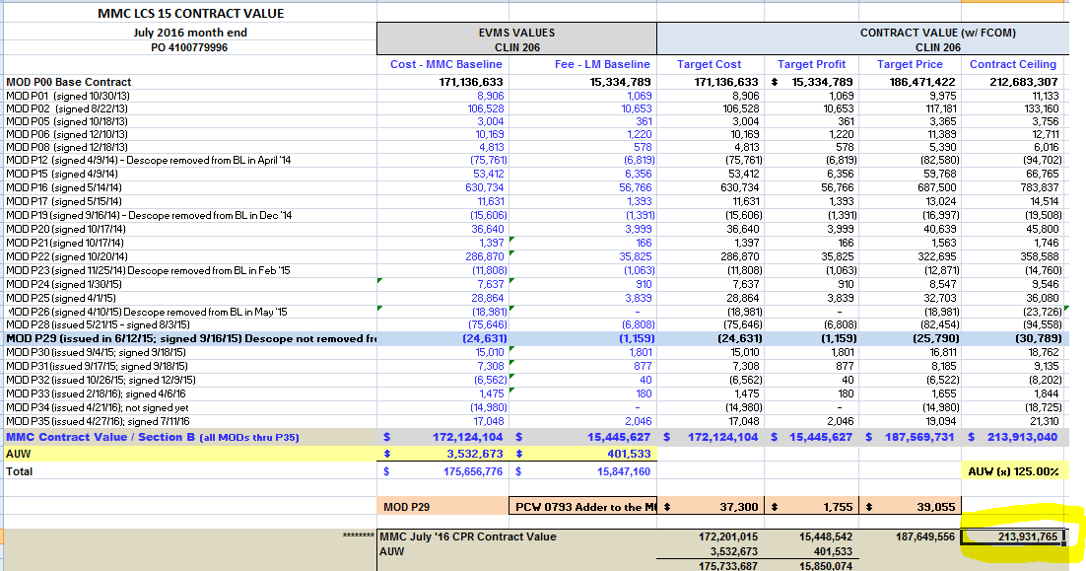

* 1921 Checks:
* Confirm the 10. Type Action b. Latest Modification is a v-lookup to the ‘Header Lookup’ tab.
* Confirm all v-lookups are working for header details.
* Update UB value matches the CPR for the “as of date” CPR.
* Profit/Loss or Fee = Estimated Price – Most Likely EAC off the PCW spreadsheet Month Year.
* Number of Units should be 1 from WBS Element 1.0 – 1.2.2
* Number of Units should be 0 for WBS Element 1.3 – 1.10
* Subtotal Cost (Recurring and Total) should match the CPR for Actual Costs and EAC.
* To the right of the table, look at the formulas that show the differences.
  + Column U and V should all be 0.
  + If they are not 0, look into why and get them to equal 0.
* If this is a “Final CSDR” report, UB needs to be explained if value is not 0.
* If this a “50% CSDR” report, no need to explain the UB value no matter what the value is, as the ship is not complete yet so there can be UB available still.
* EAC for 1.2.1 and 1.2.2 should be 0 for number of units.
* Latest Mod on 1921 must match **LATEST** PCW spreadsheet.
* Final Check:
  + File – Save as 1921
    - Copy/Paste Special Values on ‘1921’ tab.
    - Delete formulas off to the side.
    - Delete all other tabs.
  + Open the original file ‘LCS XX CSDR MM-DD-YYYY with formulas’ and File – Save as 1921-1.
    - Copy/Paste Special Values on all